AWS Task-4

Task Description:

Launch an EC2 instance (Linux and Windows) along with a web server. Then, create an EBS volume of 5 GB, attach it to an EC2 machine (Linux and Windows), and take a snapshot. Finally, create an EBS volume using the taken snapshot.

Step1:
Launch ubuntu EC2 instance with HTTP enabled
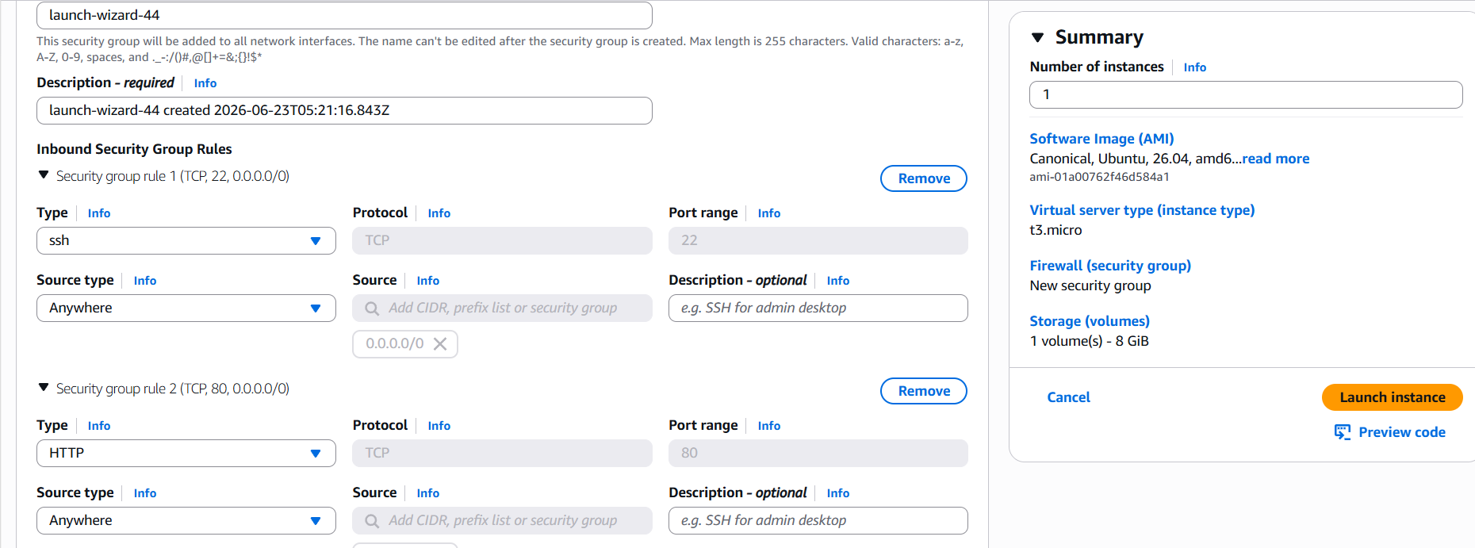

Step 2: Install apache2 webserver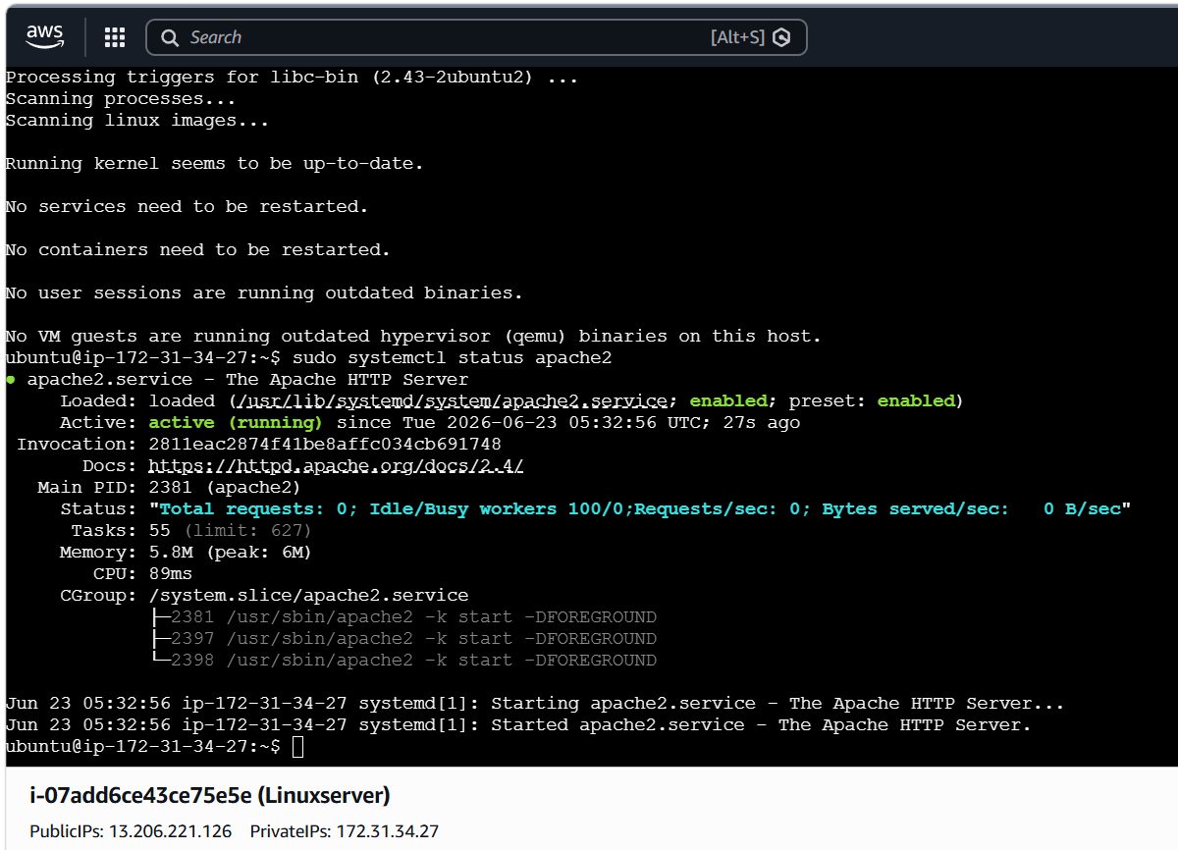

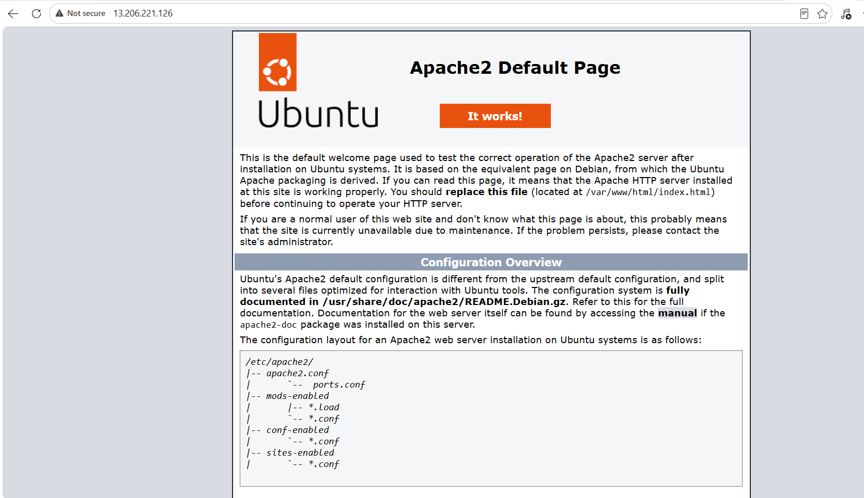

Step 3: Launch windows EC2 instance with key pair selected.

Step 4: Connecting to windows instance
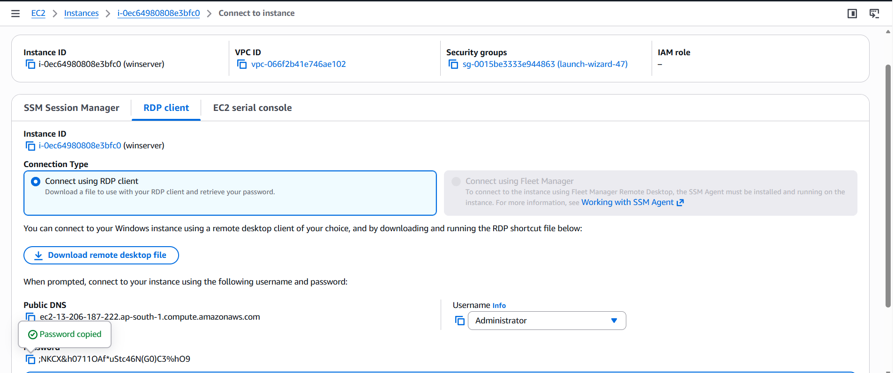

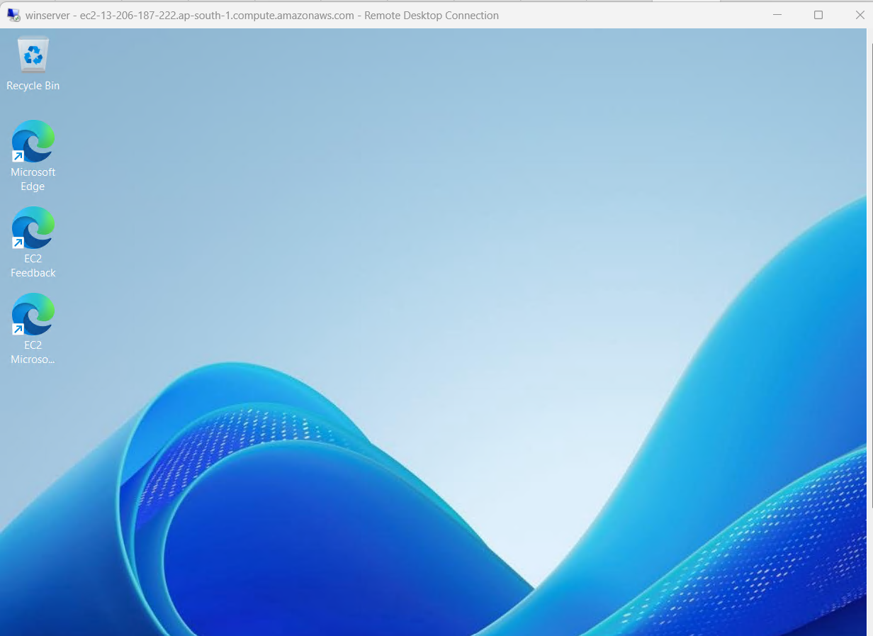

Step 5:
Install apache in windows RDP
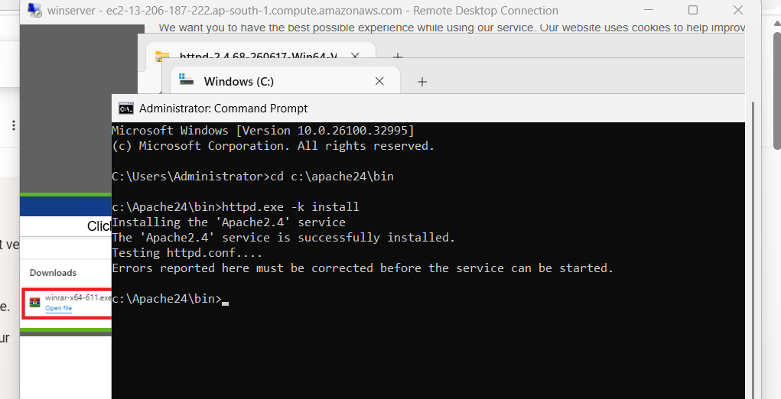

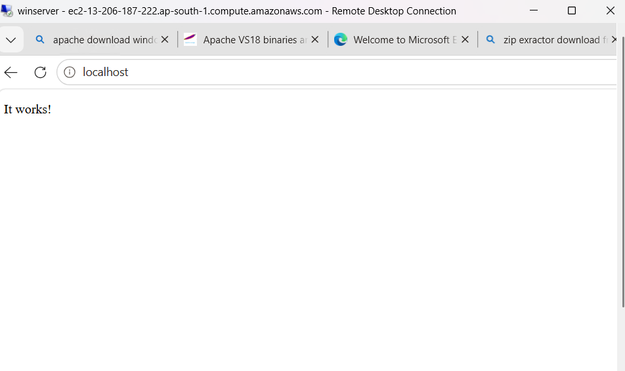

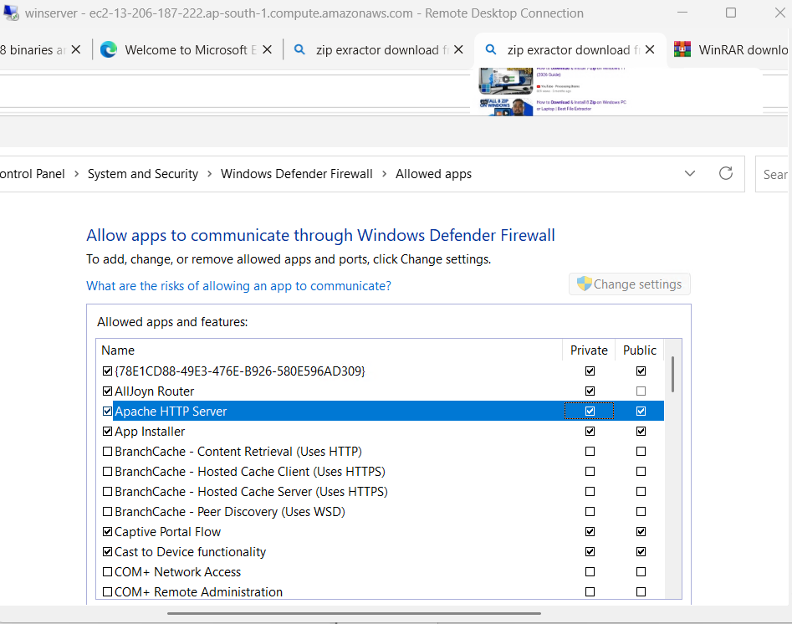

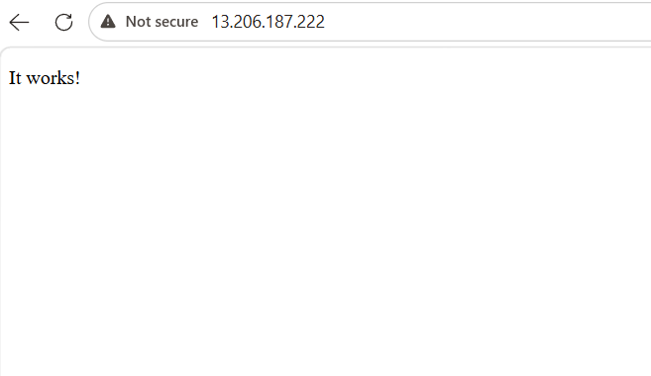

Step 6:
Created a volume with 5GB and attach to the instance
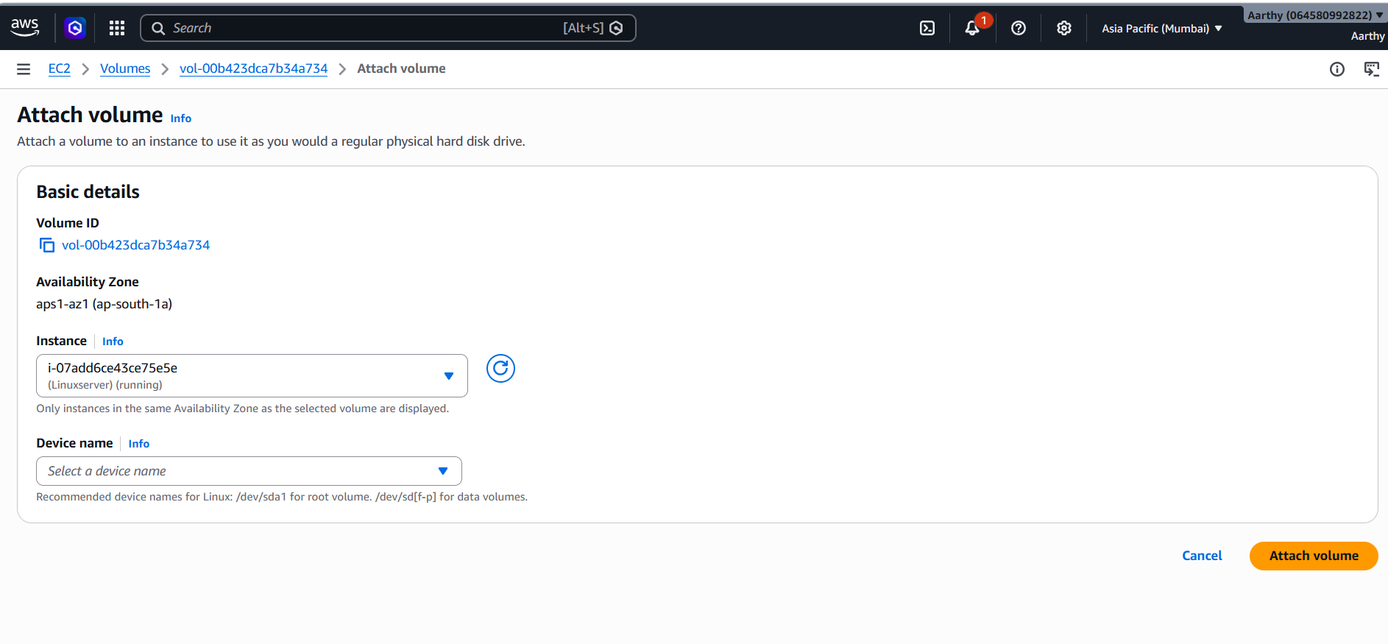

Step 7: Create a snapshot

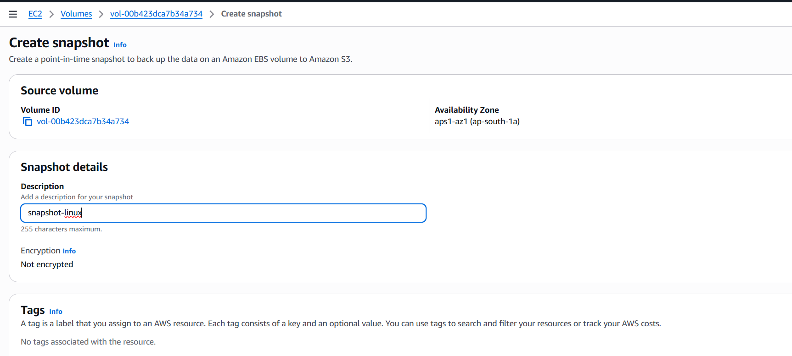

Step 8: Create a EBS volume from created snapshot

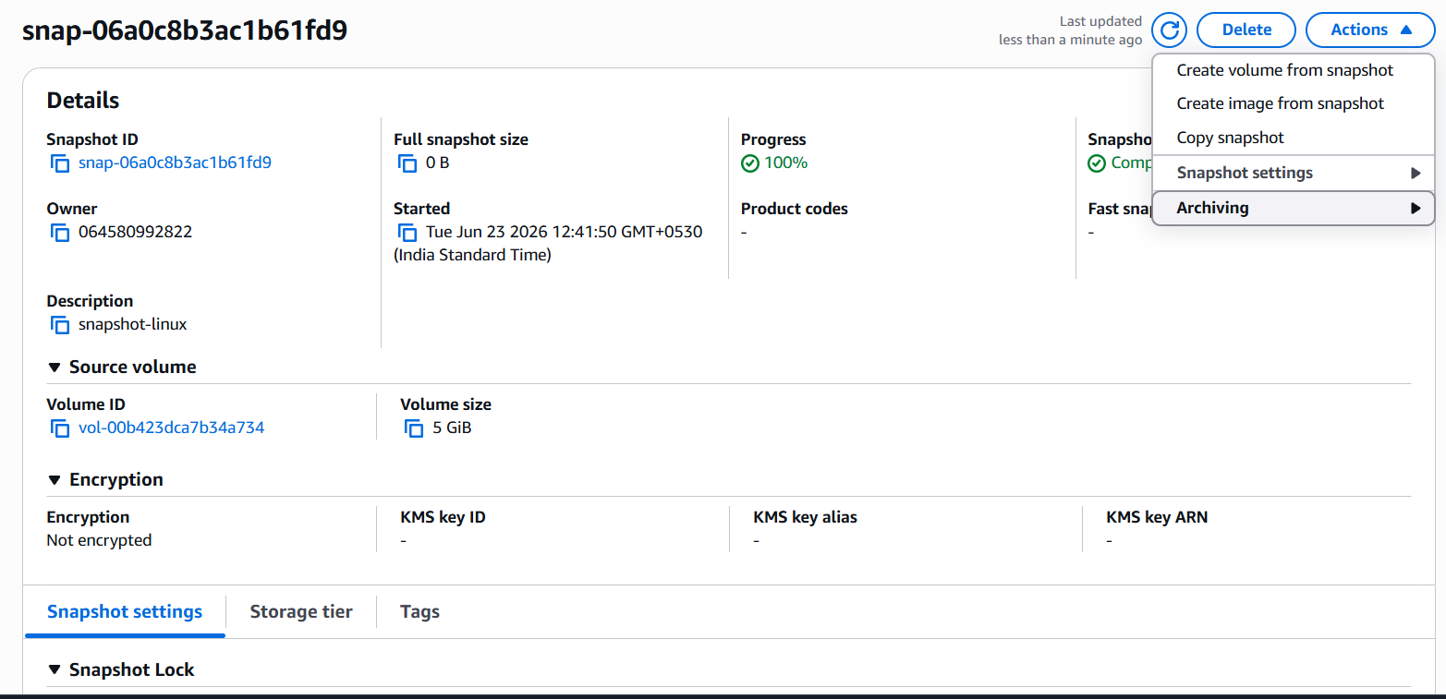
Step 9: check volumes in instances
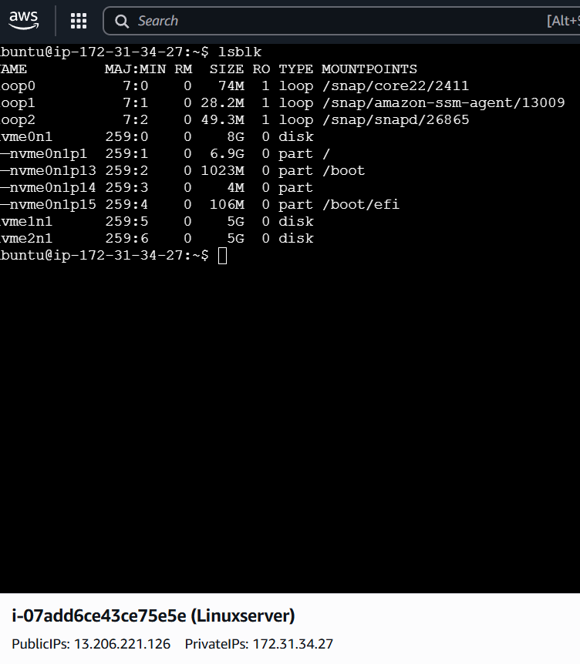

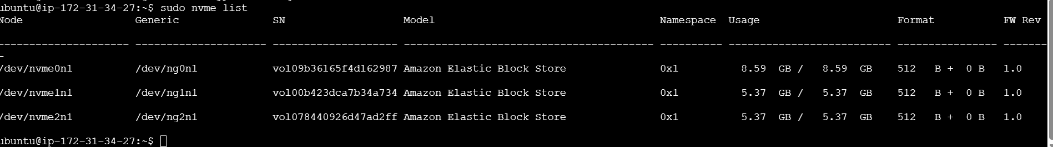

Step 10: same volumes in both instance storage tab.
